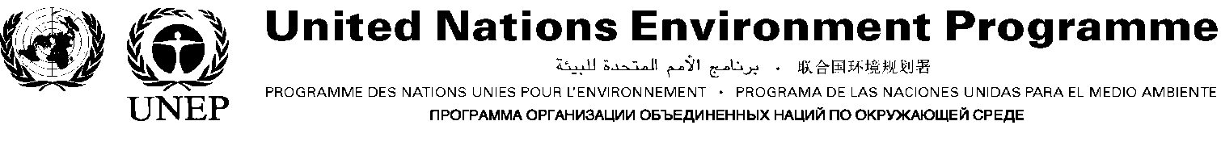

GLOBAL PARTNERSHIP ON NUTRIENT MANAGEMENT (GPNM)

Information Brief

A global partnership of scientists, policy makers, private sector, NGOs and international organisations has been formed to address the growing problem of nutrient over-enrichment. The Partnership will be launched formally on 6 May 2009 at this year’s meeting of the UN’s Commission on Sustainable Development.

Nutrients, such as nitrogen, are a key part of delivering food security and sustainable development. But excess use and inefficient practices leads to nutrient over-enrichment, causing soil acidification and groundwater pollution, harmful algal blooms and dead zones in the sea, and loss of coral and sea grass cover. As a result, marine and coastal ecosystems and the services and livelihoods they support are undermined and the resilience of ecosystems to climate change weakened.

For the benefits of nutrients to be realised effectively, including their contribution to food security, countries need access to improved information and assessment of the multiple and linked impacts of nutrients. Countries also need access to more integrated management approaches, tools and training which address the root causes of over-enrichment, and help prevent the release of excess nutrients. A global partnership, the GNMP, can help mobilise these changes.

The Partnership will raise awareness among policy makers about the causes and harmful impacts of over-enrichment, and the benefits of taking action. It will foster engagement by all stakeholders and exchange information and good practice with a view to assisting the delivery of knowledge based, remedial action and training, tailored to the circumstances of developing countries and countries in transition and their associated watersheds and coastal areas. In this way, the Partnership can help countries to engage actively in identifying and implementing cost effective and workable solutions.

Modalities: the GPNM will operate as a voluntary network of organisations and individuals, who are willing to take opportunities and work together on nutrient related activities. Drawing on the work of previous initiatives, the Partnership will provide a web based platform, presenting information on major emission sources and impacts, cross-media transfer of nutrients, environmental costs of over-enrichment, and an identification and analysis of impacts in coastal areas and Large Marine Ecosystems (LMEs. Lessons and practices developed under Global Environment Facility projects as well as nutrient management initiatives by countries and other organizations will be made available through the Partnership platform. The aim is to provide stakeholders with a consolidated source of causal impacts, their costs and future trends, and access to effective tools, approaches and training.

A key focus will be on facilitating implementation partnerships between and within countries. Using the web based information provided by the GPNM, such partnerships involving stakeholders from different countries and disciplines, will be able to identify the necessary research, policies, partners, tools and training to make informed on the ground interventions. In turn, information, approaches and lessons learned from these interventions would be made available for all partners for future use.

The GPNM will be a key initiative to help implement the Global Programme of Action for the Protection of the Marine Environment from Land-based Activities (GPA), a non binding multi-lateral environmental agreement addressing the links between watersheds and coastal systems using an ecosystem management approach.

The UNEP/GPA Co-ordination Office (www.gpa.unep.org) consistent with its role as a facilitator and catalyst for action by countries in relation to implementing the Global Programme, will set in hand initial actions and co-operation, establish an information and activity sharing system, organise meetings, and facilitate implementation partnerships and activities.

Nutrients + Eutrophication and Dead Zones

Nutrient over-enrichment of coastal waters and Large Marine Ecosystems (LMEs) is an increasing problem worldwide. Key sources of nutrients include: agriculture - in particular through fertilizer leaching, runoff from agricultural fields, manure from concentrated livestock operations and aquaculture - wastewater discharge from sewage and industry, and fossil fuel emissions. These nutrients can enter coastal and marine ecosystems through the air and riverine transport. Increased nutrients, such as nitrogen and phosphorous, can cause phytoplankton and macro algae blooms which can block light and lead to the loss of sub-aquatic vegetation (SAV). This process is known as eutrophication and can lead to fish kills and shellfish poisoning in humans. Eventually, coral reefs can be damaged and species diversity can be substantially reduced. Globally, harmful algae blooms are considerably more widespread and frequent than they were a decade ago, a situation that is expected to further deteriorate by 2020 (GIWA, 2006).

Eutrophication can lead to oxygen depletion (hypoxia) or ‘dead’ zones. Since 1960, when there were 9 documented hypoxic zones, the number of hypoxic areas has doubled every decade. A panel of experts convened under the auspices of the World Resources Institute (WRI) in 2007 identified 415 eutrophic and hypoxic coastal systems worldwide. Of these, 169 are documented hypoxic areas, 233 are areas of concern and 13 are systems in recovery (WRI, 2008). Oxygen depleted zones are now present not only in enclosed seas, such as the Baltic Sea and the Black Sea, but also in large coastal areas which have internationally important fisheries (GIWA, 2006). Eutrophication is likely to intensify in response to the increased application of fertilizers, growth in the aquaculture industry, increasing quantities of human sewage, the generation of nitrogen from fossil fuel combustion, and potentially as a result of global warming (GIWA, 2006).

From: Bricker, S., B. Longstaff, W. Dennison, A. Jones, K. Boicourt, C. Wicks and J. Woerner. 2007. Effects of Nutrient Enrichment in the Nation’s Estuaries: A Decade of Change, National Estuarine Eutrophication Assessment Update. NOAA Coastal Ocean Program Decision Analysis Series No. 26. National Centers for Coastal Ocean Science, Silver Spring, MD. 322 pp.

The Cascading Effects of Nitrogen

In addition to eutrophication, reactive nitrogen – which entails any form of nitrogen compound active in the environment - can cause a range of other, less obvious harmful impacts.

As the total production of nitrogen from human activities has accelerated, exceeding limits of utilisation and natural processes of conversion, so the global nitrogen cycle has altered. The result - known as the ‘nitrogen cascade’, is that a single molecule of reactive nitrogen may move through the environmental landscape in a variety of ways and forms. In turn, this can successively lead to a variety of environmental, health and social impacts. For example, in the air reactive nitrogen can contribute to higher levels of ozone in the lower atmosphere causing respiratory ailments and damaging vegetation. From the atmosphere, the nitrogen generally falls to the surface in atmospheric deposition, generating a series of effects – corrosion of buildings, bridges and other human–made structures, acidification of soils and other water bodies, and inadvertent fertilization of trees and grasslands, creating unnatural growth rates, nutrient imbalances and decreasing or altering of biodiversity. Leaching out into the soils, reactive nitrogen can make groundwater and surface water unfit for human consumption. Once it reaches coastal zones it can cause eutrophication, which can negatively impact fish stocks and biodiversity. Finally, a portion of reactive nitrogen is converted to nitrous oxide, which contributes to both the greenhouse effect and to stratospheric ozone depletion (UNEP/WHRC, 2006).

Given this ability of reactive nitrogen to transform in this way, policy options aimed at addressing a single impact of reactive nitrogen are unlikely to be sufficient, and indeed may result in passing the problem along the line, known as ‘pollution swapping’. This illustrates the need for an approach that considers the multiple and linked impacts, and prevents the release of excess nitrogen (UNEP/WHRC, 2006). In this regard, it is important to
consider the trade-offs and synergies that can arise between and among ecosystem services and human well-being when developing management options. And it underlines, the importance of engaging all stakeholders – including scientists, policy makers and private sector leaders – to foster better understanding of these issues and to actively engage in identifying and implementing workable solutions. A Global Partnership can assist in providing this engagement and act as a catalyst for co-operative, integrated action.

Figure 2: The nitrogen cascade

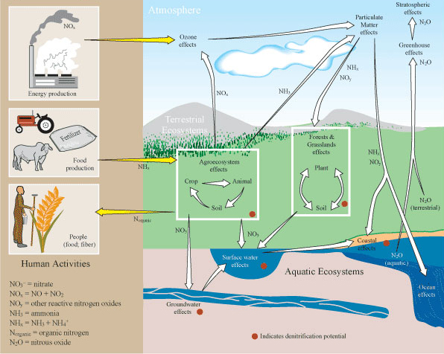

Source: adaptation from Galloway and others 2003 redrawn by Robert Smith

