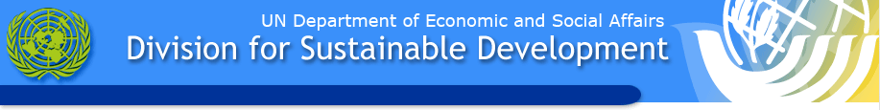

UN Commission on Sustainable Development (UN CSD)

Launch of Global Partnership on Nutrient Management (GPNM)
Wednesday, 6 May, 2009
1:15 p.m. to 2:45 p.m.
Conference Room C

You are Invited to a Special Event Hosted by:
The Government of the United States of America,
The Government of the Netherlands,
The United Nations Environment Programme

The Global Partnership on Nutrient Management (GPNM) brings together governments from around the world, international organizations, scientists, the private sector and NGOs, to address problems of nutrient over-enrichment and the need for accelerated moves towards food security, to combine the goals of increased productivity with conservation of natural resources.

Nutrients such as nitrogen and phosphorous play a key role in ensuring food security, and contributing to sustainable development. However, excess use and inefficient practices lead to soil acidification, groundwater pollution, and the undermining of marine and coastal ecosystems and the livelihoods they support. Nearly all countries and farmers can benefit from a more efficient use of nutrients and good agricultural management practices, both economically and in terms of conserving natural resources.

Often Ministries and agencies, particularly in developing countries and countries in transition, do not have the initial knowledge base and capacity to take action. Accordingly, the GPNM will provide a one-stop shop for information and capacity building, pointing policy makers and practitioners to good practices, training opportunities and the possibilities for action. A primary goal is to facilitate knowledge based partnerships between and within countries, which identify and implement cost effective and workable solutions, tailored to individual circumstances and needs.

The special event will engage a small group of policy experts and scientists from developed and developing countries, in addition to key agencies. Panelists will clarify the issues, and discuss the added value of the Partnership for countries and other stakeholders. During an inter-active discussion with the audience, core partners will explain how the Partnership is relevant to their own specific context, and discuss how interested parties can demonstrate their commitment to sound practices of nutrient management by joining GPNM. Other participants in the audience will be invited to contribute ideas and suggestions on how to ensure the success of the Partnership.

The UNEP/GPA Coordination Office, which provides the Secretariat for the GPNM, will present details on the proposed web-based platform, which is designed to provide information, tools and training opportunities from all GEF nutrients related projects, as well as those from other partners. The platform will also bring together reports and overviews on nutrients from around the world, enabling the GPNM to produce nutrient source-impact guidelines that integrate policy messages and available management tools.

Box Lunches will be provided at the event.
For further information, please contact:
Mr Anjan Datta (UNEP/GPA), Mr. Jay Benforado (USA), Mr Kaj Sanders (Netherlands ).

